Screenshots
- Code after answering questions (before first trial run):
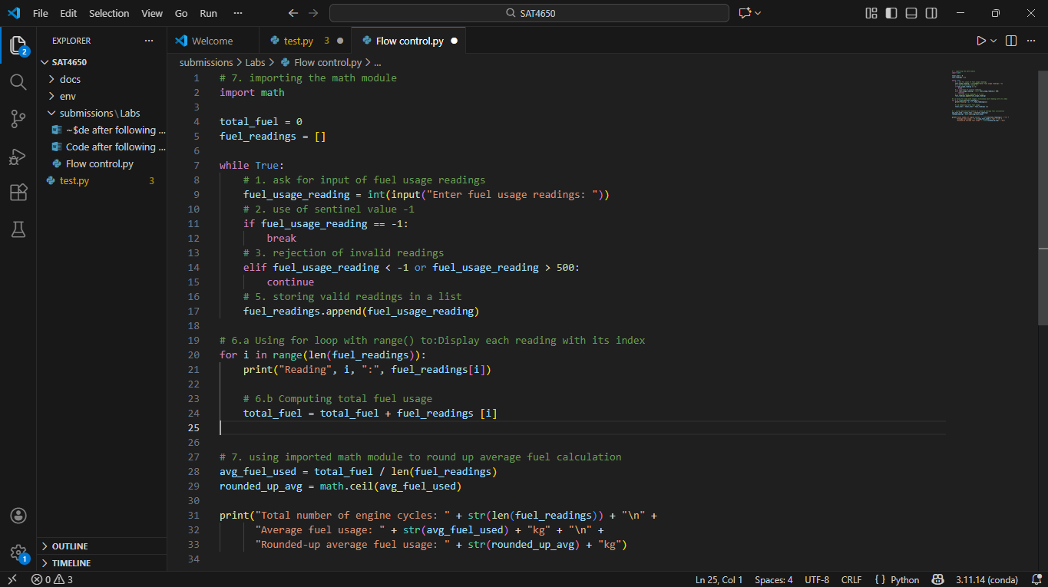
- Code with results upon first trial of inputting sample readings (50, 30, 555, 20, -1):
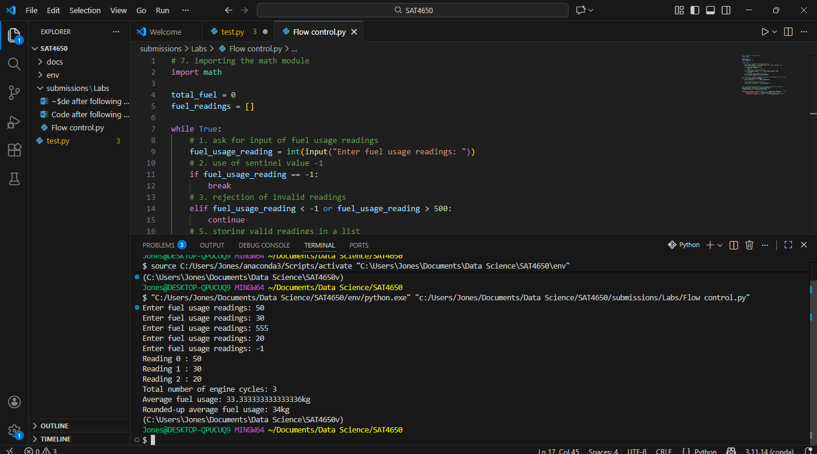
- Test results after enhancing user readability:
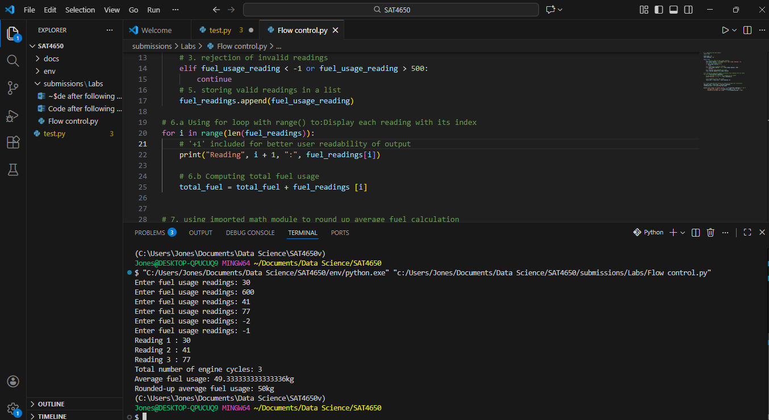
- Error after entering decimal value:
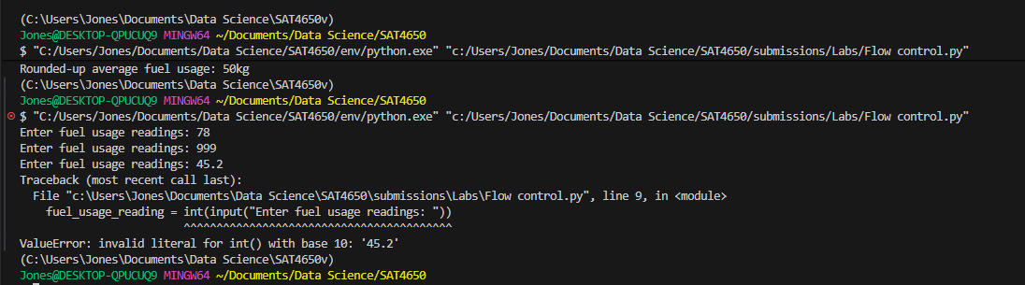
- source code enhanced for user readability :
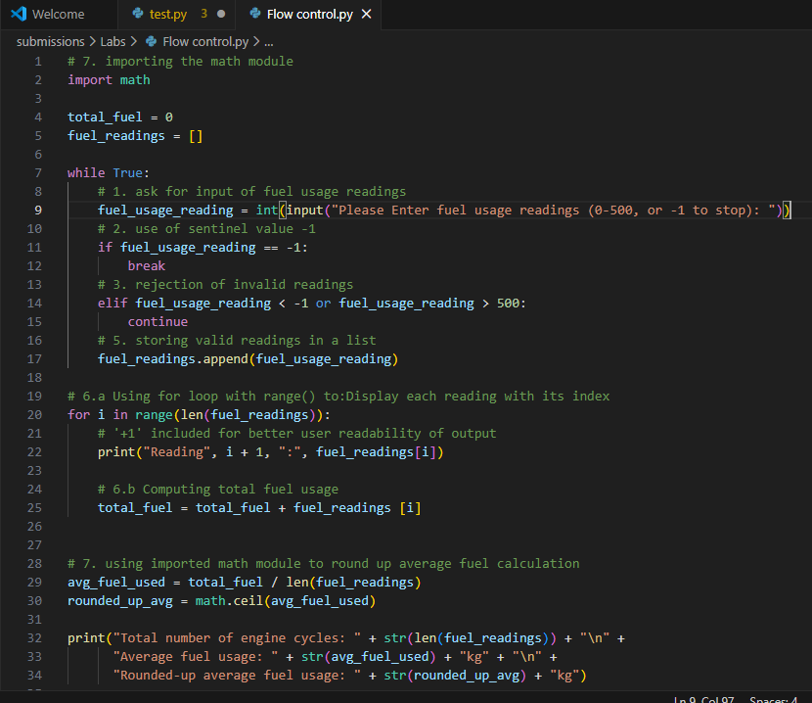
- ChatGPT code results:
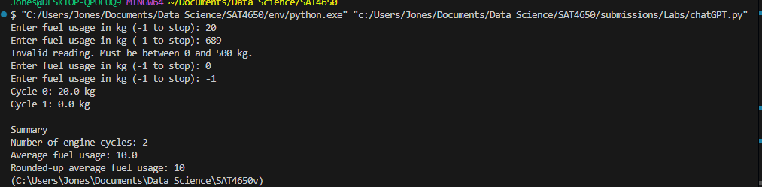
- Final source code (that displays index with fuel reading, and input variable set to float):
